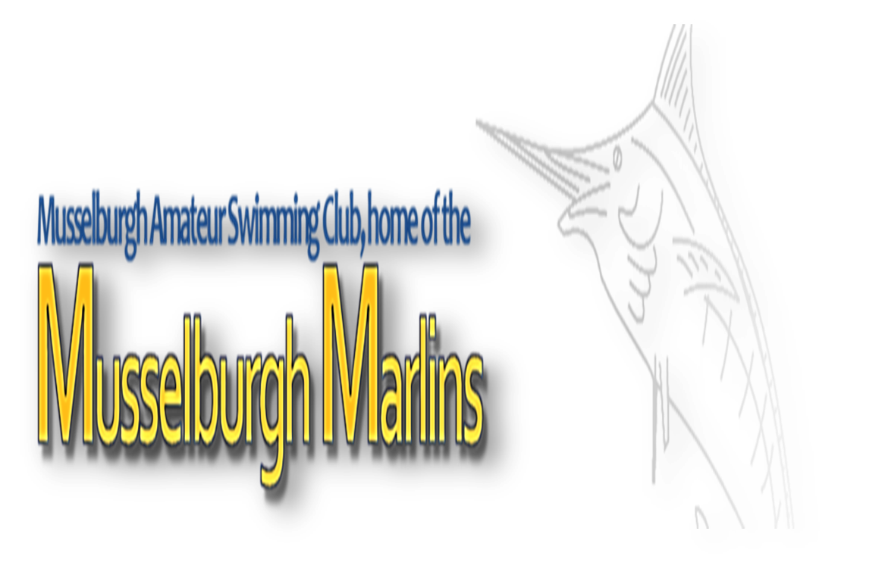

Musselburgh Amateur Swimming Club

invite you to their annual

Summer Sprint Meet

Sunday 17th June 2018

Musselburgh Sports Centre

Meet Information

Date: 17th June 2018

Venue: Musselburgh Sports Centre

Facilities: 6 lane, 25 metre, anti-wave lane ropes, cafeteria

Age Groups: Age groups will be as age on day of competition.

12 years | 13 years | 14 & Over for individual events.

12 – 13 | 14 & Over for relay events.

Events: Heats will swim as open events while finals will split into age groups.

Heats: 50m all strokes, 100m IM (HDW), 100m Freestyle (HDW)

Finals: 50m all strokes

Relays: 4x50m Freestyle and 4x50m Medley (HDW)
Should there be insufficient swimmers from an age group for a relay, clubs may swim swimmers up an age group (swimmers cannot swim down an age group).

Sessions: Morning Warm Up: 9 am Start: 10 am

Afternoon Warm Up: 1:30 pm Start: 2:30 pm

Awards: Medals will be presented to the top three swimmers/teams in each age group for each individual/relay event.

Cash prize for the best boy and best girl from each age group. Awarded to the swimmer scoring the most points from all events on the following scale: 1st = 7, 2nd = 5, 3rd = 4, 4th = 3, 5th = 2, 6th = 1. Disqualifications will score no points.

Top visiting club award – trophy presented at end of afternoon session & will be retained by the winning club for one year. Awarded to the club scoring the most points using the same scale, as outlined above, for best boy/girl.

Entry Fees: Individual Events: £23 (irrespective of the number of events entered) Relays: £7.00
Cheques should be made payable to Musselburgh Amateur Swimming Club and should be received no later than seven days after the closing date.

Officials: Clubs entering this meet should provide a minimum of two officials in order that we can apply for accreditation. Please provide these and return the completed form with your entries.

Entries:

Entries should be made on Hy-Tek entry files which can be obtained by e-mailing masccompetitionsecretary@gmail.com quoting your club name.

Should the meet be over-subscribed cuts will be made from the slowest 100 IM time to the fastest from the entries received, regardless of the number of events entered.

Entries not accepted will be refunded. Entry times will be short course times. MASC reserve the right to fill any vacant lanes with their swimmers where an event is under subscribed.

Entries should be received by 12 noon on Friday 18th May. No time cards will be required.

Entries will be accepted on a time basis. It is the responsibility of Entry Secretaries to ensure all entry times and dates of birth are correct.

A draft programme will be made available to Entry Secretaries prior to the meet date. Withdrawals on the day must be made to recorders no later than 45 minutes prior to the start of each session. There are no refunds for entries withdrawn after the draft programme is prepared.

Accreditation: SASA level 2 licence and accreditation will be applied for.

Meet Rules:

The meet shall be held under FINA and SASA Rules.

It is the responsibility of each club to ensure that their swimmers are aware of the meet rules and guidelines.

Age is as on the day of the competition.

All competitors must have current S.A.S.A. or equivalent registration numbers.

Electronic timing will not be in operation – manual timing will be used.

No photographic or video equipment will be allowed in any area within the Centre.

The organisers reserve the right to restrict entries to allow for the smooth running of the meet. Rejected entries on this basis will be refunded in full.

Over the top starts may be used to help the smooth running of the meet.

Swimmers must report to the marshalling area four heats in advance.

Warm up:

Warm up may only commence when advised to do so.

No diving other than in sprint lanes.

The meet stewards will determine sprint lanes.

No congregating allowed at either end of the lanes.

Miscellaneous:

The organisers reserve the right to exclude or refuse admission to any competitor, spectator or team official.

Neither Musselburgh ASC nor Musselburgh Sports Centre can be held responsible for loss or damage to any property. Swimmers should use the lockers provided and not leave belongings lying around unattended. Bags should not be taken onto poolside they should remain in lockers.

Swimmers must act on the instructions of the meet officials and behave in a responsible manner at all times.

To avoid the unnecessary waste where empty lanes appear, reserves will be drawn from the reserve list.

No glassware may be taken into the showers or poolside. Anyone doing so will be liable to expulsion from the meet.

Outdoor footwear must not be worn on the poolside area.

Swimmers MUST wear dry clothing and footwear at all times when not in poolside area.

Limited viewing space is available.

The use of mobile phones is prohibited by Musselburgh Sports Centre anywhere within the building.

Musselburgh ASC retains the right to amend any of the above conditions as necessary.

Anything not covered in the above or in the event programme will be at the organisers’ discretion.

No guarantee can be given by Musselburgh ASC that the event will take place at a particular time, place or date and Musselburgh ASC reserve the right to reschedule the event without notice and without liability for doing so. It is expected that this would only be as a result of unforeseen circumstances, e.g. venue/facility failure or adverse weather.

In the event of postponement, cancellation or abandonment of the event, refunds if, any, will be made at the absolute discretion of Musselburgh ASC. Musselburgh ASC will have no liability to make a refund or to pay any form of consequential or indirect damage such as loss of enjoyment, travel and accommodation costs.

Schedule of Events

Session 1: Warm Up: 9 am Start: 10 am

Event Number | Gender | Event
101 | Girls | 100m | Individual Medley | HDW
102 | Boys | 50m | Freestyle | Heats
103 | Girls | 50m | Breaststroke | Heats
104 | Boys | 50m | Butterfly | Heats
105 | Girls | 50m | Backstroke | Heats
106 | Boys | 100m | Freestyle | HDW
107 | Boys | 50m | Freestyle | Finals
108 | Girls | 50m | Breaststroke | Finals
109 | Boys | 50m | Butterfly | Finals
110 | Girls | 50m | Backstroke | Finals
111 | Girls | 200m | Freestyle Relay | HDW
112 | Boys | 200m | Medley Relay | HDW

Session 2: Warm Up: 1:30 pm Start: 2:30 pm

Event Number | Gender | Event
201 | Boys | 100m | Individual Medley | HDW
202 | Girls | 50m | Freestyle | Heats
203 | Boys | 50m | Breaststroke | Heats
204 | Girls | 50m | Butterfly | Heats
205 | Boys | 50m | Backstroke | Heats
206 | Girls | 100m | Freestyle | HDW
207 | Girls | 50m | Freestyle | Finals
208 | Boys | 50m | Breaststroke | Finals
209 | Girls | 50m | Butterfly | Finals
210 | Boys | 50m | Backstroke | Finals
211 | Boys | 200m | Freestyle Relay | HDW
212 | Girls | 200m | Medley Relay | HDW

Musselburgh Summer Sprint Meet – Sunday 17th June 2018

Entry Form

Name of Club |  | Club Code
Contact Name |  | Address
Email |  | Telephone
Number of male entries | @£23.00 |  | Total £
Number of female entries | @£23.00 |  | Total £
Number of Relay entries | @ £7.00 |  | Total £
 | Total no of entries |  | Total amount enclosed £

Signed: _______________________________________

Position: _______________________________________

Please make cheques payable to: Musselburgh Amateur Swimming Club

Send summary sheet and cheque by post to: | Or pay by bank transfer and email to:
Andrew Torrance  40 Brunstane Bank  Edinburgh  EH15 2NR | masccompetitionsecretary@gmail.com  Sort code: 80-17-68  Account: 00221095

Closing date for entries is 12 noon on Friday 18th May 2018

Health and Safety Declaration

This form must be completed and returned with your entry cheque.

- I confirm that all swimmers are current members of SASA and have paid the appropriate membership fee.

- I understand that any swimmer entered without a SASA registration number will be automatically rejected.

- I confirm that all swimmers have trained and are competent to dive in the pool, any swimmer unable to do so, will start in the water and notify the referee in advance.

Signed:__________________________________

Print Name:______________________________

Club:____________________________________

Position:__________________________________

Date:_____________________________________

Named STO’s and Timekeepers

Name | Position | Sessions | Preferred Role | Contact Details
 | STO/TK | 1 [ ] 2 [ ]
 | STO/TK | 1 [ ] 2 [ ]
 | STO/TK | 1 [ ] 2 [ ]
 | STO/TK | 1 [ ] 2 [ ]
 | STO/TK | 1 [ ] 2 [ ]
 | STO/TK | 1 [ ] 2 [ ]
 | STO/TK | 1 [ ] 2 [ ]
 | STO/TK | 1 [ ] 2 [ ]
 | STO/TK | 1 [ ] 2 [ ]
 | STO/TK | 1 [ ] 2 [ ]
 | STO/TK | 1 [ ] 2 [ ]

- Please complete and return to masccompetitions@gmail.com.

- While every effort will be made to accommodate requests for preferred roles and mentoring, this decision lies with the meet referee based on available officials.

- Thank you for your assistance.

Musselburgh ASC Committee

